 | Document Number | EDCS-XXXXXX
 | Based on Template | EDCS-228142 Rev 18
 | Created By | Kumar Anurag

Multicast Server Client Design
SDS for Parallel Computation using Multicast

Reviewers

Department | Name/Title
Development Engineering
Customer Advocacy(PLM)

Modification History

Revision | Date | Originator | Comments
1 | 23/11/2014 | Kumar Anurag | Initial Draft

Table of Contents
1 Abstract 4
2 Multicast Server Client Architecture 4
2.1 Problem Definition 4
2.1.1 Multicast Server 4
2.1.2 Multicast Client 4
2.1.3 Data to be stored and displayed on standard output 5
2.2 Design Considerations 5
2.3 Functional Structure 5
2.4 System Flow 6
2.5 Data Structures 7
2.5.1 Group Member list 7
2.5.2 Server 7
2.5.3 Client 7
2.6 Description of Algorithms 7
2.7 Interface Design 8
2.8 End User Interface 9
2.9 Software Restrictions and Considerations 9
2.10 Firmware Restrictions and Considerations 9
2.11 Hardware Restrictions and Considerations 9
2.12 External Restrictions and Configuration 9
2.13 Source Code 9
2.14 Development Unit Testing 9
3 Initiative, Legal, & Regulatory 9
4 References 9
5 Glossary 10
6 Attachments 10
6.1 Review Action Items 10

List of Tables and/or List of Figures are optional and may be deleted.

List of Tables
Table 2.x: <name of table> Error! Bookmark not defined.

List of Figures
Figure 1: <name of figure> Error! Bookmark not defined.

Abstract
This document describes the detailed design of Parallel Computation using Multicast Server Client Architecture.

Multicast Server Client Architecture

Problem Definition

Multicast Server
- Server is supposed to execute a given task. It can distribute the divided tasks to be executed by set of clients in a multicast group.
- Server should keep track of which client belongs to which multicast group
- Server will be able to collate the results from clients and display the results taken from each of the clients.
- It also should display the percentage of task executed
- Server functionality should be extensible i.e. In future, it should be easy to define a new task that server can execute.
- Server should be able to handle multiple simultaneous response from clients.
- Server should have mechanism to detect response timeout from client.
- Server should be able to detect that particular client is down( heart-beat can be used to detect) and hence the request to execute a particular task cannot be given to that client.
- Server should store information about all multicast groups and all clients e.g. client address, port, which groups a particular client belongs to.
- Server can use TCP/UDP based on needs in order to communicate.

Multicast Client
- There can be maximum of 255 client per Multicast group. Groups can be upto 1000. Hence max 255*1000 clients can be there simultaneously.
- A Client can join a single group or multiple groups.
- Clients need to perform a given task asked by Server.
- After completing the task Client should send the result back to Server.
- Client should have a mechanism to come out of infinitely executing task , if it could not perform a given task within a given maximum time allowed.
- Clients should perform heart beat exchange mechanism in order to detect whether server is up/down.

Data to be stored and displayed on standard output
- Server should display current membership list, task being executed and the percentage of task finished.
- Display the task name and how the task input was taken i.e. from file or from standard input.
- Remove a client from multicast group

Design Considerations
Following points can be taken into account while considering design
- Protocol/Message format for communication between server and client.
a) Server Request message
b) Client Response message
c) Prune Request message from server to client
d) Hear-Beat Message between client-server to check if nodes are alive

- UDP Multicast message from Server to client, TCP message from client to server.
- Server will store the group list and client list in a global data structure.
- In the beginning Server will be capable of executing single task. But design will be made such a way that multiple task can be executed by a server.
- To cater above point 4 needs, Server can fork child process for each of the task.
- Clients can be run on a single machine via different process. Also clients can sit on different machine.
- Server will start first and then fork can be executed on the basis on number of tasks.
- There will be client program which can be invoked in one/all machines to start the clients. We can maintain the client list and the group to join to be run on single machine in a file and pass the argument to master client program.

Functional Structure
Following are the modules/directory that will be performing different functionality.
- multicast_server -> It will have functionality to perform the given task and result. It also has additional functionality of display the group list, task execution.
- multicast_client -> functionality to join a group and perform a given task. We can have task module which will specifically contain algorithms to be used by client to perform a given task.
- Encode-decode module for encoding/decoding for Request and Response message to/from client
- protocol/message format -> text file having detailed info on what each message type is meant for.
- group-member info -> this module will have data structure where list of groups and clients info can be filled and retrieved.
- Heartbeat -> short module meant for exchanging messages between client and server to check if corresponding node is up/down.

System Flow
<This is partial work, other message flow needs to be added>
1. Delivering task to client from server

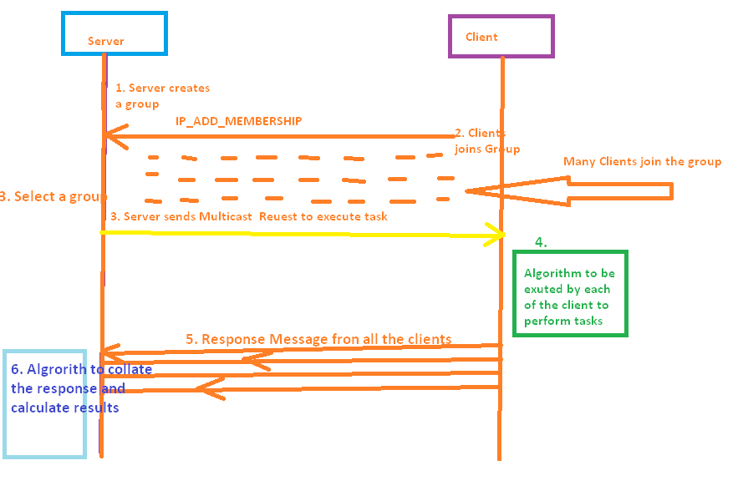

Data Structures

- Each client can be identified its IP address and port number and also multicast group.
- A server handling single task will be identified by its IP address and port number.
If Server handles multiple task, then its port number will differ.

Group Member list
- TODO Client List data structure –
Each client can be distinguished by its IP Address and port number and variable argument of groups to which it belongs. There can be maximum of 255*1000 unique clients.
- TODO Multicast Group data structure –
There can be a maximum of 1000 groups and each group can have 255 clients.

Server
- TODO Local Data structure required at Server

Client
- TODO Local Data Structure required at each client.

Description of Algorithms
To be done

Interface Design
Encoder/
Decoder
Encoder/
Decoder

Multicast Group1
Client1

Server
Client2

Client3

Machine1

Client1
Client2

Groups and Member info
Client3

Machine2
---- Multicast Request Message to Client
---- Response message from client to Server

End User Interface

To be done

Software Restrictions and Considerations
To be done

Firmware Restrictions and Considerations
To be done.

Hardware Restrictions and Considerations
To be done.

External Restrictions and Configuration
To be done.

Source Code
To be done.

Development Unit Testing

To be done

Initiative, Legal, & Regulatory
<CPDM requirement>
<Body>

References
- <Name of document in italics>, <document info in plain text>
- <Name of document in italics>, <document info in plain text>

Glossary
The following list describes acronyms and definitions for terms used throughout this document:
- Term 1 <in bold>: <definition in plain text>
- Term 2 <in bold>: <definition in plain text>

Attachments

Review Action Items
<body>

For guidelines in creating documents using this template, see Template Instructions. For Template comments please contact cpdm-input alias.
End of Document

